COSC 412

Group 4 Project

Kate Borowy

Carter Lyons

Jack Taormino

Hamza Sheikh

Zeeshan Haider

Seth Graham

**Table of Contents**

1. Introduction

1.1 Overview

1.2 Deliverables

1.3 Evolution of SPMP

2. Project Organization

2.1 Process Model

2.2 Organizational Structure

2.3 Organizational Interface

2.4 Project Responsibilities

3. Managerial Process

3.1 Management Objectives and Priorities

3.2 Assumptions, Dependencies and Constraints

3.3 Risk Management

3.4 Monitoring and Controlling Mechanisms

4. Technical Process

4.1 Methods, Tools, and Techniques

4.2 Software Documentation

4.3 Project Support Functions

5. Work Elements, Schedule, Budget

5.1 Work Breakdown Structure

Revision Sheet

10/13: Process model revised, Group members assigned to teams, teams designated tasks.

10/17: Coding tool found and programming languages found out.

10/20: Database, hosting, and login API found.

11/17: Finalized gantt chart.

Introduction

1.1 Overview

The purpose of this project is to work with our client, the Healthy Lifestyles committee of the US Department of Health and Human Services, to create a gaming-based website. This website will be designed to educate adults on how to live a healthy life. Our game will allow users to take care of a virtual pet in order to keep it healthy and happy, while also receiving tips on how to stay healthy. This will be a fun and interactive game to keep people interested in learning how to achieve healthy lifestyle goals. The game will be accessible on all devices. Since this is only a semester-long project, we will present a prototype to our customer at the end of the term for approval as well as long-term solutions to complete and run the website.

1.2 Deliverables

* Mid - Semester Group Project Status Presentation October 13th, 2020
* Group Project Presentation December 12th, 2020

1.3 Evolution of SPMP

* Revision

Project Organization

2. Project Organization

2.1 Process Model

We will be using the waterfall model.

2.2 Organizational Structure

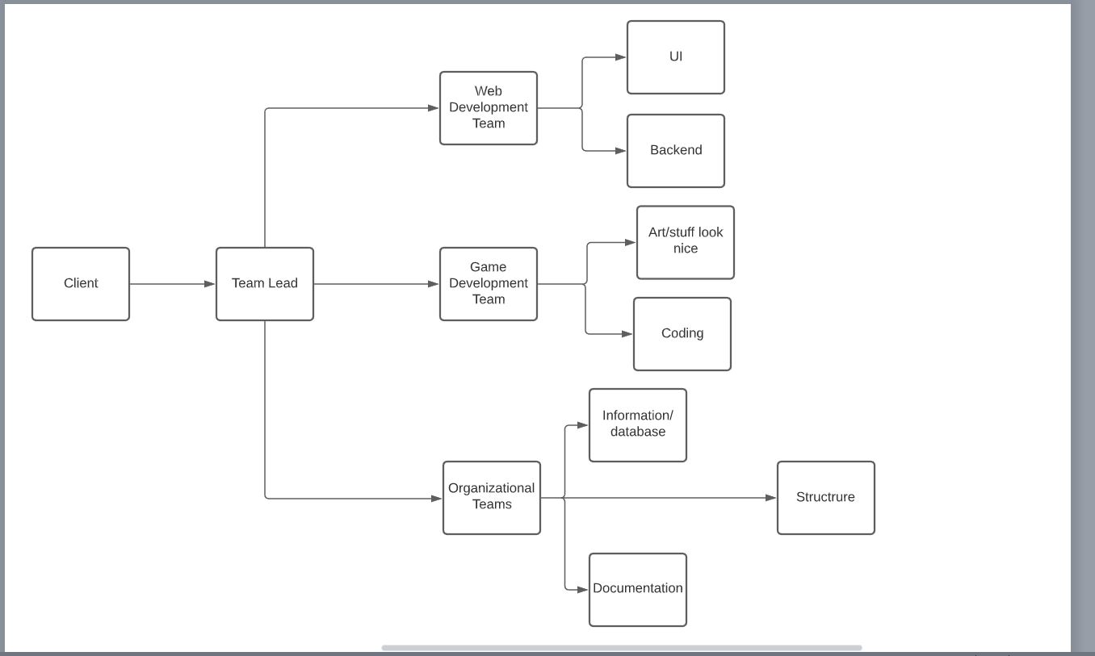

2.3 Organizational Interface

Hosting Services

2.4 Project Responsibilities

Team Lead- **Seth:** Talk with client, keep them updated on progress of the project. Inform team of any changes.

Development team- Work on making a clean and effective game website that is up to specifications requested by the client.

Sub teams:

Possibly move one game team member to website team if need arises

* Game Team:Seth, **Jack**, Kate B
* Implementation of Character Models
* Implementation of Single player, co-op, and multiplayer
* Website Team: **Carter,** Zeeshan, Hamza
* Find Hosting Service
* Find Database
* Look into game integration
* Design User Friendly UI

Managerial Process

3.1 Management Objectives and Priorities

* We need to keep in contact with our client to make sure our program is to their standards. We will have frequent meetings where we can ask questions about their program requirements.
* Keeping everyone on task and finishing their components on time.

3.2 Assumptions, Dependencies and Constraints

* Assumptions/Dependencies
  + Advertisements
    - Advertisements will be related to the product: healthy lifestyle products and information.
  + Donations
    - Users will be able to pay for pet cosmetics or ad-free play as a form of donations to the client company.
    - Users will also have the option to make a donation to the client’s organization without receiving anything in return.
* Constraints
  + Time: We have until the end of November to finish a working prototype.
  + Money: Since the client will be paying for the project, they need to make sure that they can afford the upkeep of the product. If the client runs out of money we stop working on the program.

3.3 Risk Management

* As part of our contract, if the client can no longer afford our services, we have the right to leave the project
* We will take into consideration every new development idea of our program, if it is feasible.
* If the project becomes too complex, we will need to reevaluate the project to ensure that we are hitting the priorities of the client.
* To reduce risk of rewriting or overwriting the program, we will have frequent meetings with the client to maintain the course of the end product.

3.4 Monitoring and Controlling Mechanisms

* The schedule and weekly meetings will keep everyone focused and completing their components on time.

Technical Process

4.1 Methods, Tools, and Techniques:

* Languages: HTML5, CSS, JavaScript
* Development: VS Code
* Database: Firebase
* Login: Firebase
* Version Control: Github
* Web hosting: Name.com

4.2 Software Documentation

* Documentation exists to provide product functionality, combine project - related information and allow space to talk about any questions or concerns between stakeholders and developers.
* Documentation plan:
  + From the start to finish, the documentation goes over different aspects of the projects such as: high level requirements, test plans, test documentation, system documentation, installation guides, user manual and the final report. Below, we will expand over each part of the plan.
  + High level requirement:
    - User Registration account: User should be able to create an account to save data
    - User Log in: User should be able to log in after an account has been created
    - Donation System: Able to send donations through sandbox mode
    - Game: If the game is able to show you progress
  + Test plan:
    - Able to look at user registrations in the firebase database
    - Able to check whether a user is logged in through the console
    - Play through the game to figure out if functionality works
  + User manual
    - Navigation bar that lists out pages specific to the user such as game, login,etc.
    - Scroll down for more information
  + Final report:
    - Our frontend and backend are seamlessly integrated with our required database and client/server side APIs’ - our game was developed based on our requirements and is fully functional.

4.3 Project Support Functions

* Testing:
  + Test plans
  + Test procedures
  + Unit testing
    - Individual testing for functions/classes.
  + Integration testing
    - Testing all classes/Interfaces together
  + Acceptance(final test)
* Configuration control
  + Program code changes
  + Requirements and design changes
  + Game versions?
* Quality assurance:
  + Smooth and efficient.

Work Elements, Schedule, Budget

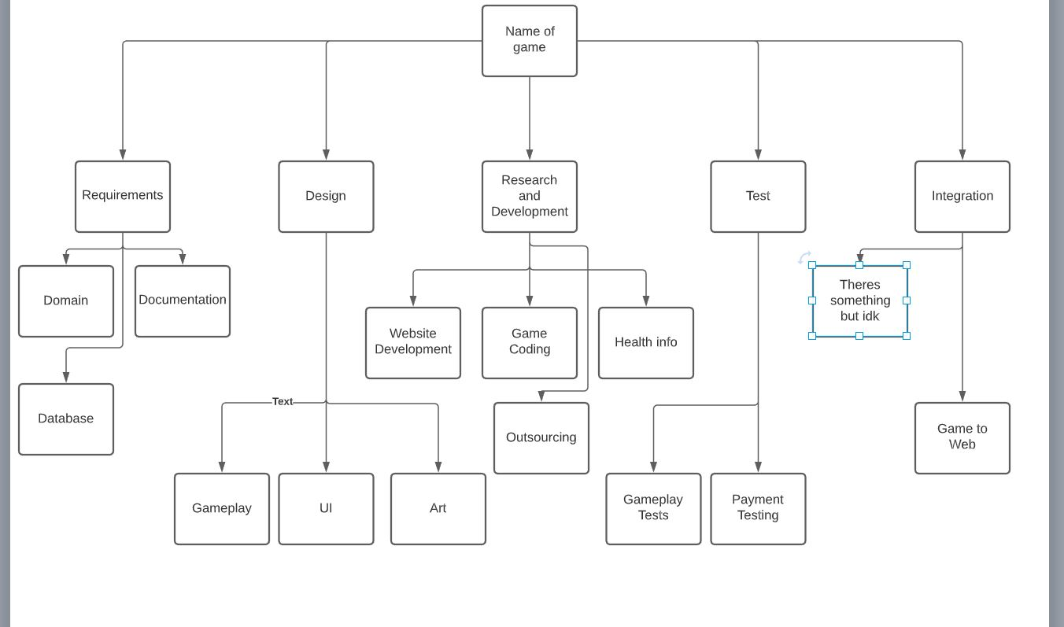**Schedule:** 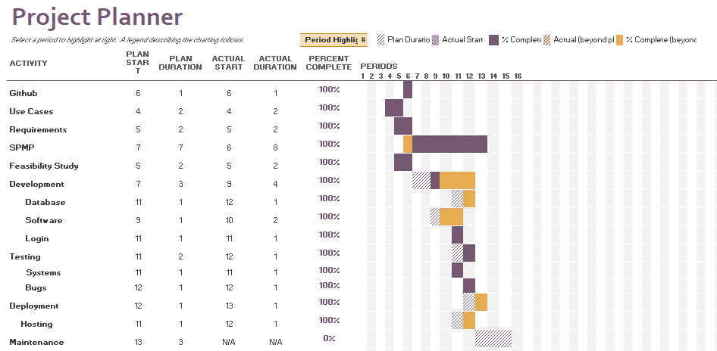

**Budget:**

* Homie Art: $30
* Domain and Website Hosting: $15